### UNIT 1

### BipolarJunctionTransistor

* Both electrons and holes participate in the conduction process for bipolar devices.
* BJT consists of two *pn* junctions constructed in a special way and connected in series, back to back.
* The transistor is a three-terminal device with emitter, base and collector terminals.
* From the physical structure, BJTs can be divided into two groups: ***npn*** and ***pnp***

transistors.

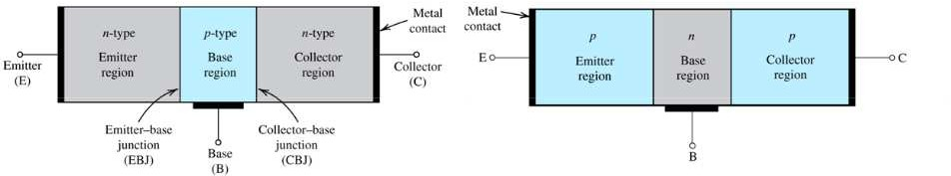

##### Modes of operation:

* + The two junctions of BJT can be either forward or reverse-biased.
  + The BJT can operate in different modes depending on the junction bias.
  + The BJT can operate in different modes depending on the junction bias.
  + Switching applications utilize both the cutoff and saturation modes.

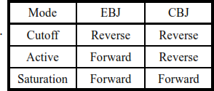

##### Operation of the *npn* transistor in the active mode:

* + Electrons in emitter regions are injected into base due to the forward bias at EBJ.
  + Most of the injected electrons reach the edge of CBJ before being recombined if the base is narrow.
  + Electrons at the edge of CBJ will be swept into collector due to the reverse bias at CBJ.
  + Emitter injection efficiency(y) = iEn/

(i

En

+ iEp)

* + Base transport factor(α ) = iCn/

T i

En

* + Base transport factor(α) = iCn/i = yαT < 1

E

* + Terminal currents of BJT in active mode:

iE(Emitter current) = iEn(electron injection from E to B) + iEp(hole injection from B to E)

iC(Collector current) = iCn(electron drift) + iCBO(CBJ reverse saturation current with

emitter open)

iB(Base current) = iB1(hole injection from B to E) + iB2(recombination in base region)

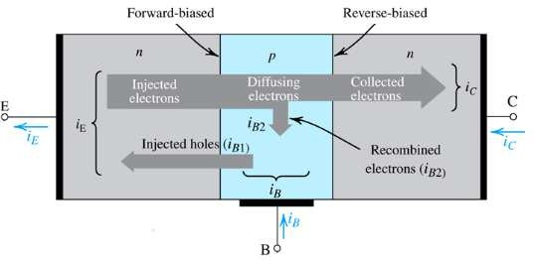

### The transistor as an amplifier:

* + A BJT circuit with a collector resistor *R*C can be used as a simple voltage amplifier.
  + Base terminal is used the amplifier input and the collector is considered the amplifier output.
  + The voltage transfer characteristic (VTC) is obtained by solving the circuit from low to highVBE.
  + Cutoff mode:

0V ≤ VBE < 0.5V & iC = 0 VO = VCE = VCC

* + Active mode:

VBE > 0.5V & iC ≠ 0 VO = VCC − iCRC

* + Saturation mode:

VBE further increases

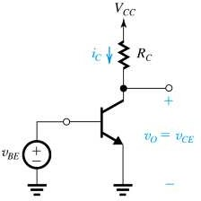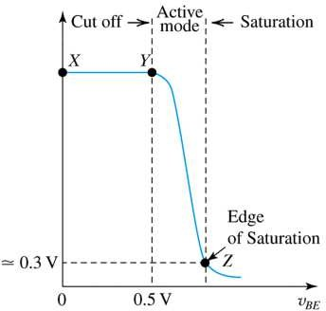VCE = VCE(cat) = 0.2V VO = 0.2V

### Transistor Configuration:

Depending upon the terminals which are used as a common terminal to the input and output terminals, the transistors can be connected in the following three different configuration.

1. common base configuration
2. common emitter configuration
3. common collector configuration

##### Common base configuration:

* + In this configuration base terminal is connected as a common terminal.
  + The input is applied between the emitter and base terminals. The output is taken between the collector and base terminals.

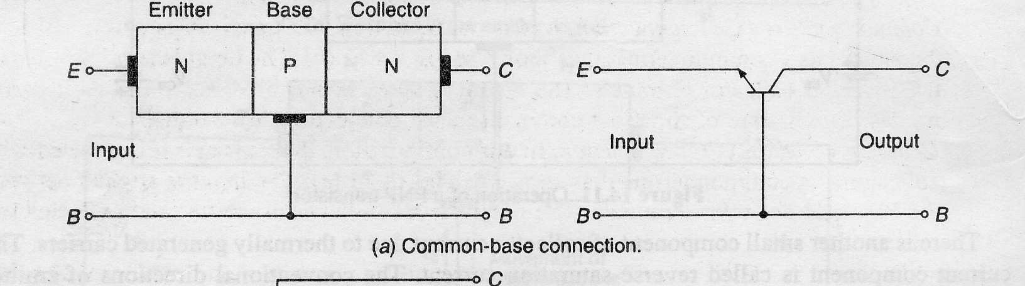

* + Input characteristics: The output (CB) voltage is maintained constant and the input voltage (EB) is set at several convenient levels. For each level of input voltage, the input current **IE** is recorded. **IE** is then plotted versus **VEB** to give the common-base input characteristics.
  + Output characteristics: The emitter current **IE** is held constant at each of several fixed levels. For each fixed value of **IE ,** the output voltage **VCB** is adjusted in convenient steps and the corresponding levels of collector current **IC** are recorded. For each fixed value of **IE, IC** is almost equal to **IE** and appears to remain constant when **VCB** is increased.

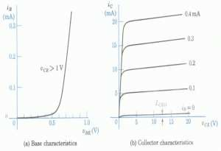

##### Common emitter configuration:

* + In this configuration emitter terminal is connected as a common terminal.
  + The input is applied between the emitter and base terminals. The output is taken between the collector and base terminals.

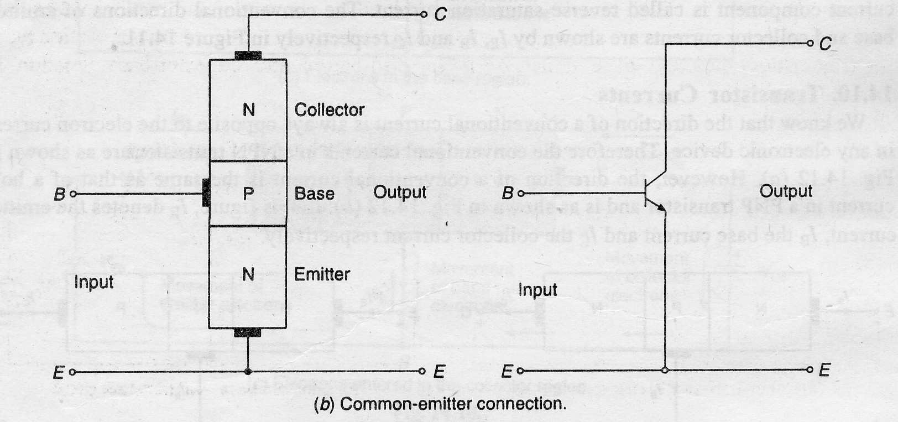

* + Input characteristics: The output voltage **VCE** is maintained constant and the input voltage **VBE** is set at several convenient levels. For each level of input voltage, the input current **IB** is recorded. **IB** is then plotted versus **VBE** to give the common-base input characteristics.
  + Output characteristics: The Base current **IB** is held constant at each of several fixed levels. For each fixed value of **IB ,** the output voltage **VCE** is adjusted in convenient steps and the corresponding levels of collector current **IC** are recorded. For each fixed value of **IB, IC** level is Recorded at each **VCE** step. For each **IB** level, **IC** is plotted versus **VCE** to give a family of characteristics.

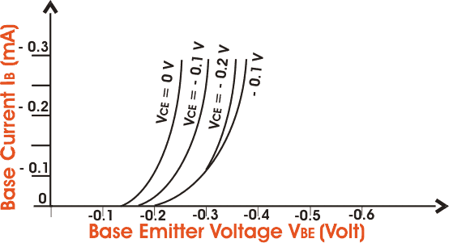 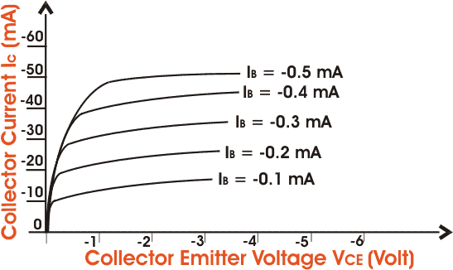

##### Common collector configuration:

* + In this configuration collector terminal is connected as a common terminal.
  + The input is applied between the base and collector terminals. The output is taken between the emitter and collector terminals.

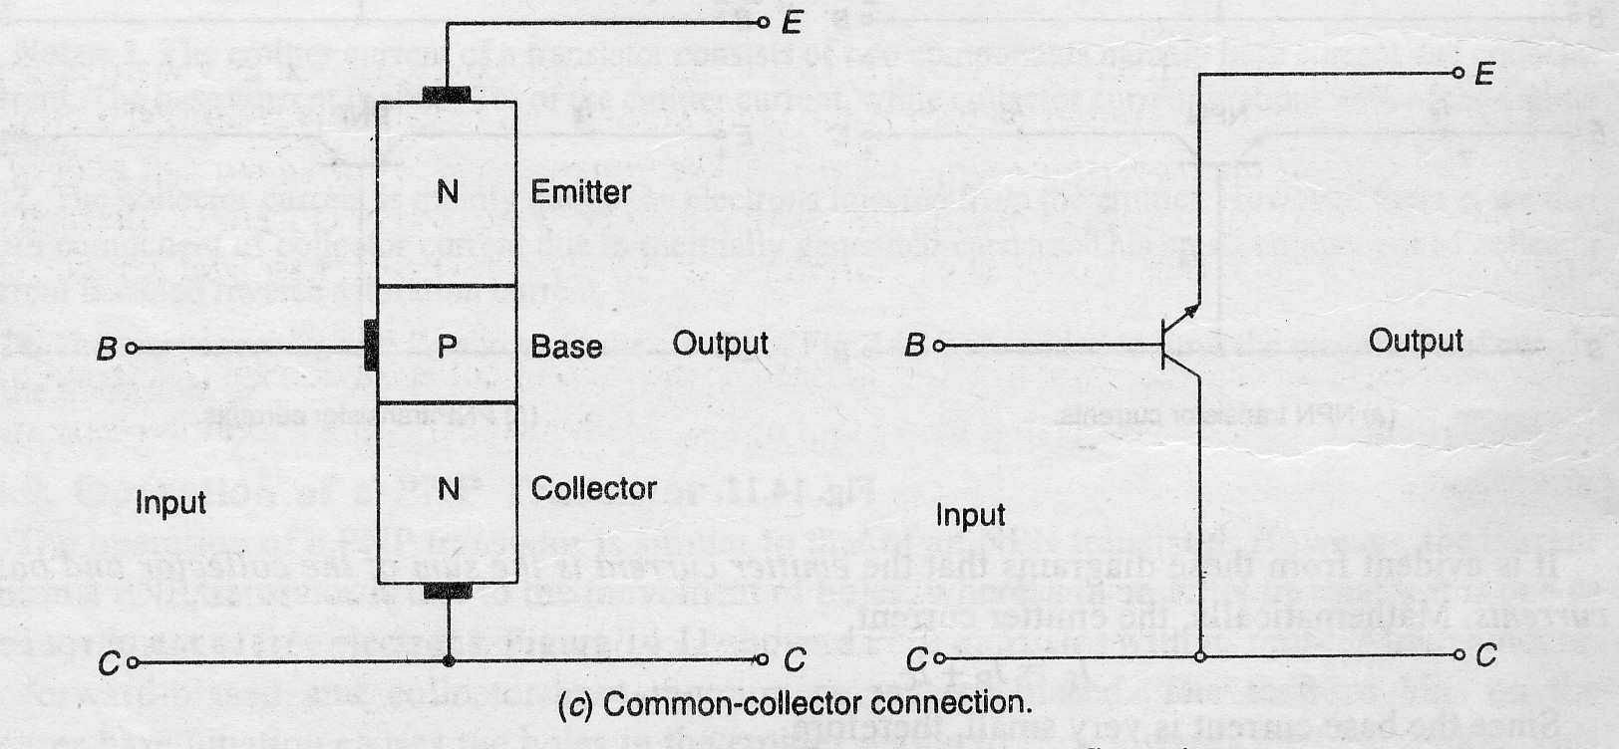

* + Input characteristics: The common-collector input characteristics are quite different from either common base or common-emitter input characteristics. The difference is due to the fact that the input voltage **(VBC)** is largely determined by **(VEC)** level.

**VEC = VEB + VBC VEB = VEC - VBC**

* + Output characteristics: The operation is much similar to that of C-E configuration. When the base current is **ICO**, the emitter current will be zero and consequently no current will flow in the load. When the base current is increased, the transistor passes through active region and eventually reaches saturation. Under the saturation conditions all the supply voltage, except for a very small drop across the transistor will appear across the load resistor.

